IPMI Firmware Update (AMI)
In WEB-GUI/DOS/WIN/Linux

Firmware Updates in WEB-GUI:

  - Click < Update Firmware > under Maintenance
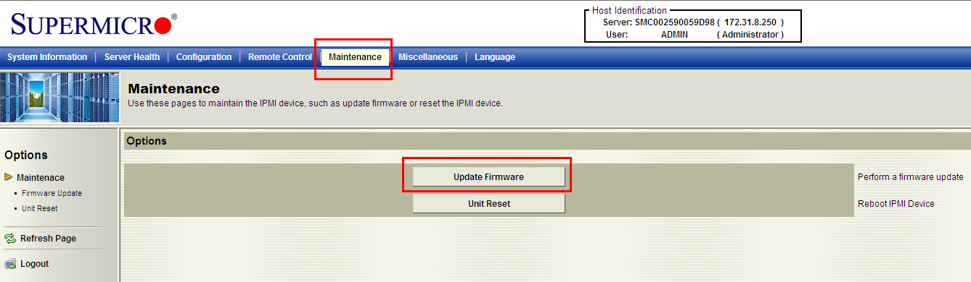
1.2 Click <Enter Update Mode> to enter the update mode. A warning message will display. Warning: Once the server is in the firmware update mode, the device will be reset, and the server will reboot even if you cancel firmware updating.
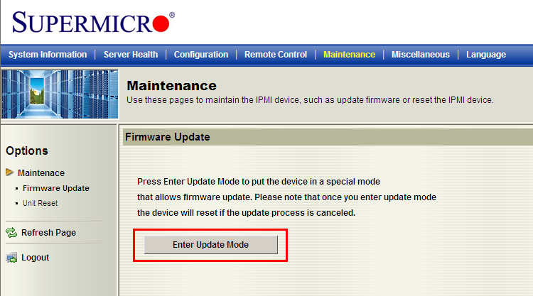

1.3 Click <OK> to update your IPMI firmware. Once you've clicked OK to update the firmware, the Firmware Upload screen will display as shown on the next page. Press the Browse button to choose firmware file and then press the Upload Firmware button to start.
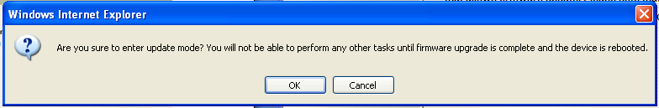

1.4 Make sure the firmware version is correct before you can press the “ Upload Firmware ” button for updating progress.
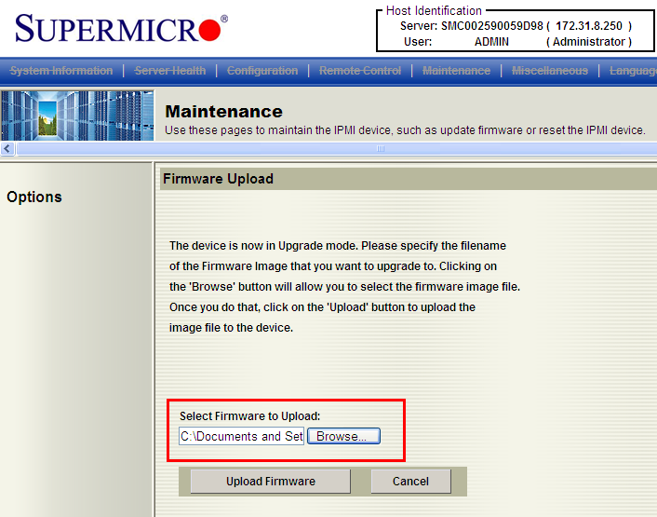

1.5 If Click <Cancel> to cancel firmware updates. Once you have clicked <Cancel > to update the IPMI Firmware, the following Firmware Upload screen will display as shown below.
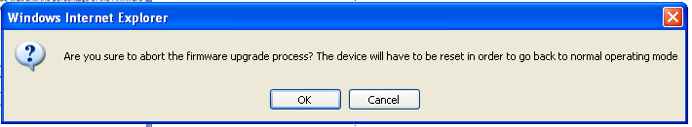

1.6 Click <Upload Firmware> to install the selected firmware to the host server.
Warning! To properly update your firmware, do not interrupt the process until the process is completed. Once it is completed, the system will automatically reboot, and you will need to login to the server again.
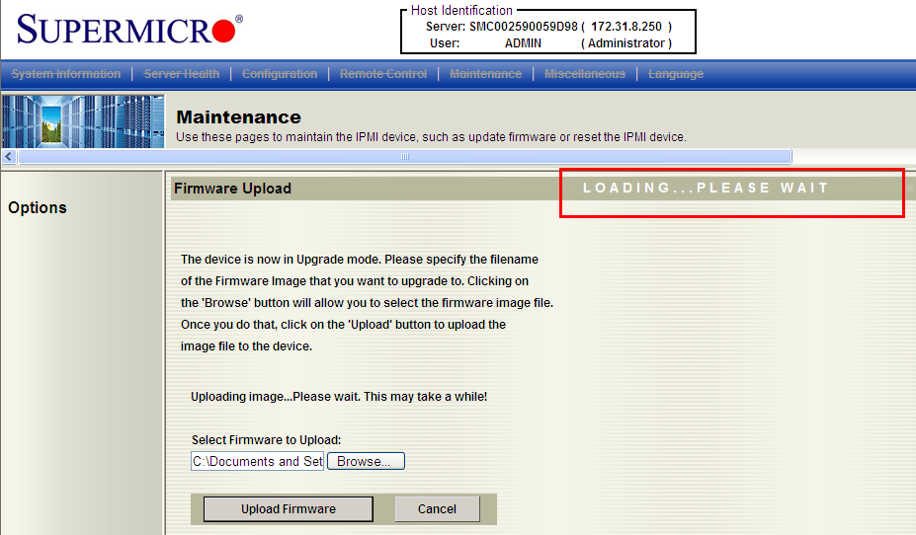

1.7 Click < OK > to confirm and start to loading.
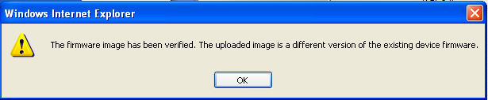

1.8 To verify the Existing Version and New Version before start upgrade.
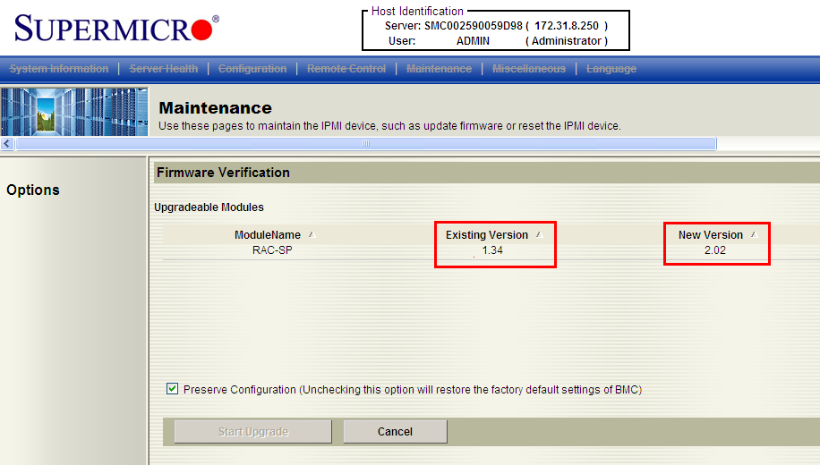
NOTE !!! Uncheck preserve configuration box during flashing (very important step for FW to work properly). All settings will be reset to default.
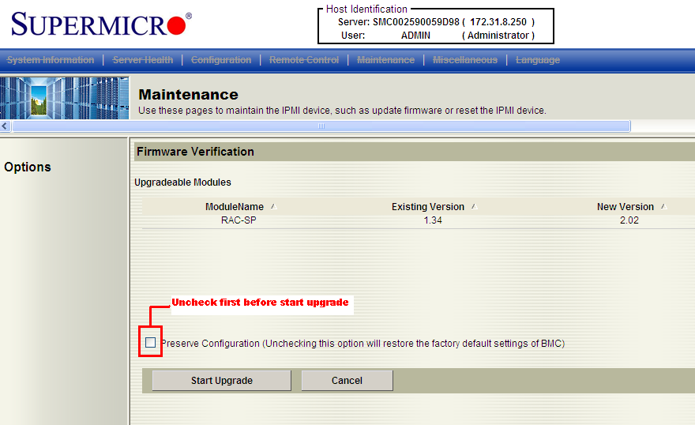

1.9 Click < OK > to install the new firmware.
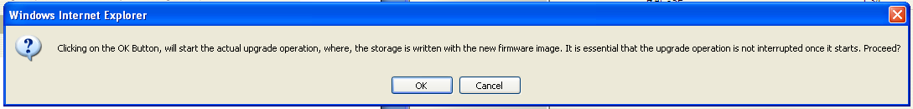
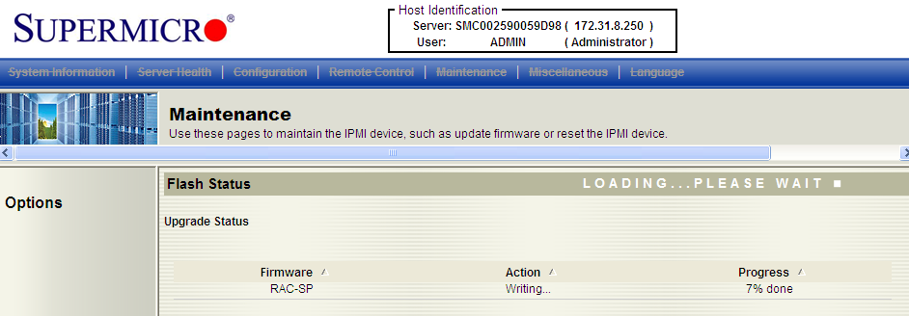

2.0 System will reboot after upgrade complete. The web page will redirect to the login page automatically.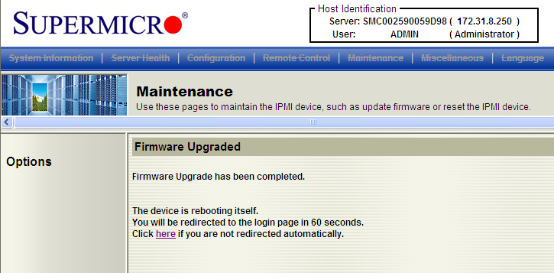

Firmware Updates in DOS / Windows / Linux

Using Flash Tools

Overview

The Flash Tools allow the user to use Command_Line (CL) utility programs to upgrade or update firmware via different channels such as KCS, USB and LAN connections. We are going to focus on the following tools in this manual.

- YAFUFlash
- YAFUKCS
• YAFUFlash

YAFUFlash (Yet Another Firmware Upgrade Flash) allows the user to flash the BMC in both Linux and Windows environments via network or USB connections. You can choose to use network connections or USB connections to flash the BMC based on how you use the flash tools.
• YAFUKCS

YAFUKCS (Yet Another Firmware Upgrade Keyboard Controller Style) is used to flash the firmware in the DOS environment via the KCS (Keyboard_Controller_Style) interface.

Flashing the BMC Firmware in the DOS Environment

YAFUKCS is the tool used to flash the BMC firmware in DOS through the KCS interface. To flash the BMC, follow the instructions below:
- Copy the files <filename>.ima, yafukcs.exe to the bootable USB stick.
If you don’t have a bootable USB stick you can make it using:
http://www.softpedia.com/get/System/Boot-Manager-Disk/BootFlashDOS.shtml).
You can download Yafukcs tool from here:
ftp://ftp.supermicro.com/utility/IPMI%20FW%20flash%20tools/AMI/DOS 2.4.zip
- At command prompt type --- yufukcs -full <filename>.ima.
- Power cycle the system after firmware upgrade.
OR

1. Copy yafukcs.exe into your DOS machine.
2. Run the yafukcs utility.
3. Use the settings as listed below.
• Format:
Yafukcs [OPTION] [FW_IMAGE_FILE]

[OPTIONS]

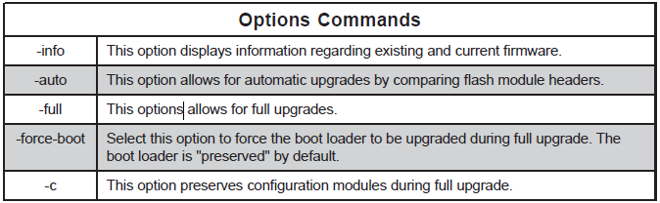

[FW_IMAGE_FILE]
The firmware-image file name is [rom.ima].

Examples
• Example 1

/Yafukcs -info rom.ima

Description: This command displays the details of both existing and new firmware.

• Example 2

/Yafukcs -full rom.ima

Description: This command starts flashing the new rom.ima to the firmware.

• Example 3

/Yafukcs -full -force-boot rom.ima

Description: This command starts flashing the new rom.ima to the firmware using
"FORCE BootLoader upgrade."

Flashing the BMC Firmware in the Windows Environment

YAFUFlash is used to flash the BMC firmware in Windows through USB or Network connections. To flash the BMC in Windows, follow the instructions below.

- Open Command Prompt. Go to YafuFlash\Windows\path.
- The following two fi les will be displayed:
- Yafuflash.exe
- LIBIPMI.dll
3. Run "Yafuflash.exe" in the command prompt.
4. Use the settings as listed below.
• Format:
Yafuflash [OPTION] [MEDIUM] [FW_IMAGE_FILE]

[OPTIONS]

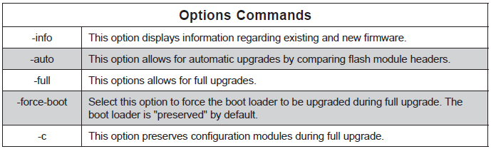
[MEDIUM]
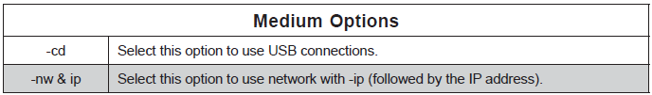

[FW_IMAGE_FILE]

The firmware-image file name is [rom.ima].

Examples

Using Network as a Medium
• Example 1
Yafuflash -nw -ip 155.166.132.12 -info rom.ima

Description: This command displays the details of both existing and new firmware using the network connection with the ip address of 155.166.132.12.

• Example 2
Yafuflash -nw -ip 155.166.132.12 -full rom.ima

Description: This command starts flashing the new rom.ima to the firmware using the network connection with the IP address of 155.166.132.12.

• Example 3
Yafuflash -nw -ip 155.166.132.12 -full -force-boot rom.ima

Description: This command starts flashing the new rom.ima to the firmware with
FORCE BootLoader Upgrade via the network connection using the IP address of 155.166.132.12.

Using USB as a Medium

• Example 1
Yafuflash -cd -info rom.ima

Description: This command displays the details of both existing and new firmware
using a USB connection.

• Example 2
Yafuflash -cd -full rom.ima

Description: This command starts flashing the new rom.ima to the firmware using a USB connection.

• Example 3
Yafufl ash -cd -full -force-boot rom.ima

Description: This command starts flashing the new rom.ima to the firmware with FORCE BootLoader Upgrade using a USB connection.

Flashing the BMC Firmware in the Linux Environment

YAFUFlash is used to flash the BMC firmware in the Linux environment using network or USB connections. To flash the BMC in Linux, follow the instructions below.

- Open the Terminal. Go to YafuFlash/Linux path.
- The file libipmi.so 1 should be accessible to a Linux system. Usually when running an application, Linux will search for a file in dependent libraries in default locations, such as usr/lib/lib folders.

- Copy libipmi.so.1 to /lib or /usr/lib. Run "1dconfig"

or

Copy libipmi.so.1 to a folder and issue the following command:
#LD_LIBRARY_PATH=<location_of_libipmi_so>/Yafuflash
Note: You may have to create a link to libipmi.so.1.0 (ln-sf libipmi.so.1.0 libipmi.so.1).

4. Run "Yafuflash.exe" in the terminal.

5. Use the settings as listed below.
• Format:
/Yafuflash [OPTION] [MEDIUM] [FW_IMAGE_FILE]

[OPTIONS]

[MEDIUM]

[FW_IMAGE_FILE]

The firmware-image file name is [rom.ima].

Examples

Using Network as a Medium

• Example 1
/Yafuflash -nw -ip 155.166.132.12 -info rom.ima

Description: This command displays the details of both existing and new firmware using the network connection with the IP address of 155.166.132.12.

• Example 2
/Yafuflash -nw -ip 155.166.132.12 -full rom.ima

Description: This command starts flashing the new rom.ima to the firmware using the network connection with the IP address of 155.166.132.12.

• Example 3
/Yafuflash -nw -ip 155.166.132.12 -full -force-boot rom.ima

Description: This command starts flashing the new rom.ima to the firmware with FORCE BootLoader Upgrade via the network connection using the IP address of 155.166.132.12.

Using USB as a Medium

• Example 1
/Yafuflash -cd -info rom.ima

Description: This command displays the details of both existing and new firmware using a USB connection.

• Example 2
/Yafuflash -cd -full rom.ima

Description: This command starts flashing the new rom.ima to the firmware using a USB connection.

• Example 3
/Yafuflash -cd -full -force-boot rom.ima

Description: This command starts flashing the new rom.ima to the firmware with FORCE BootLoader Upgrade using a USB connection.

Firmware Recovery

If the firmware upgrade is interrupted during firmware flashing, please follow the steps listed below for firmware recovery using Yafukcs.

1. Power off the system by disconnects the power cord.

2. Boot to DOS and flash the firmware using Yafukcs.

