IPMI Firmware Update
In WEB-GUI/DOS/WIN/Linux

Firmware Updates in WEB-GUI:

  - Click < Firmware update > under Maintenance
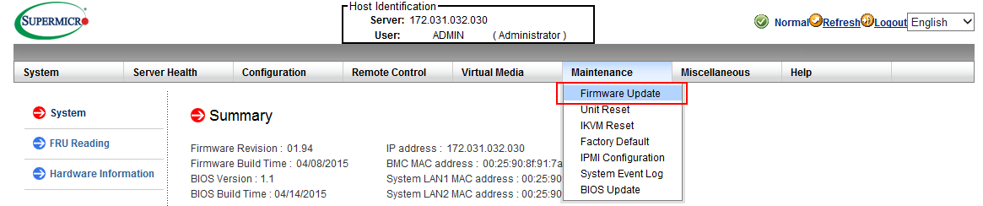
1.2 Click <Enter Update Mode> to enter the update mode. A warning message will display. Warning: Once the server is in the firmware update mode, the device will be reset, and the server will reboot even if you cancel firmware updating.
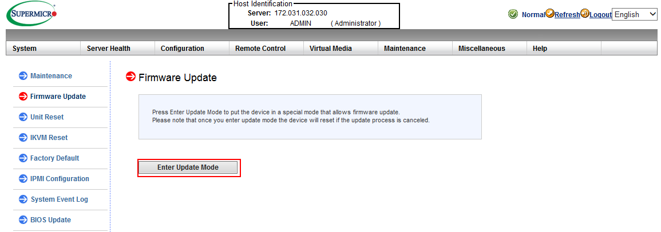

1.3 Click <OK> to update your IPMI firmware. Once you've clicked OK to update the firmware, the Firmware Upload screen will display as shown on the next page. Press the Browse button to choose firmware file and then press the Upload Firmware button to start load
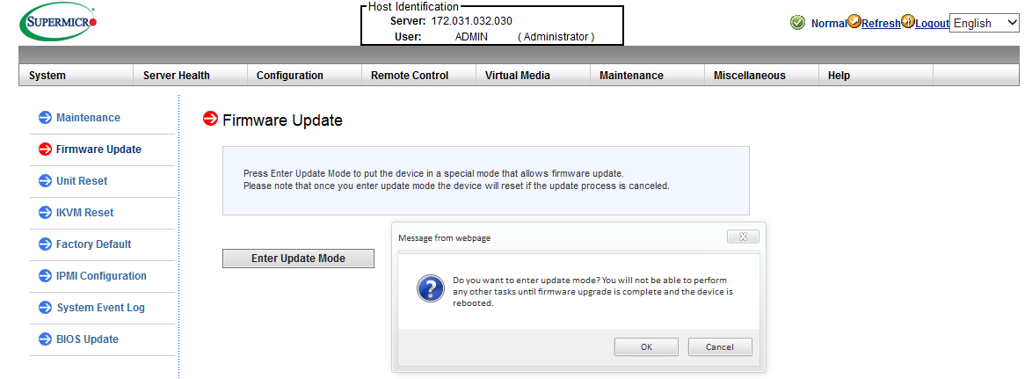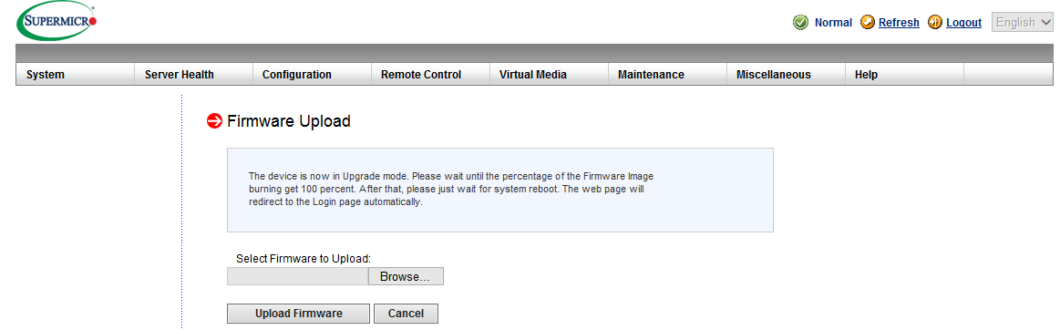

1.4 Make sure the firmware version is correct before you can press the “ Upload Firmware ” button for updating progress.
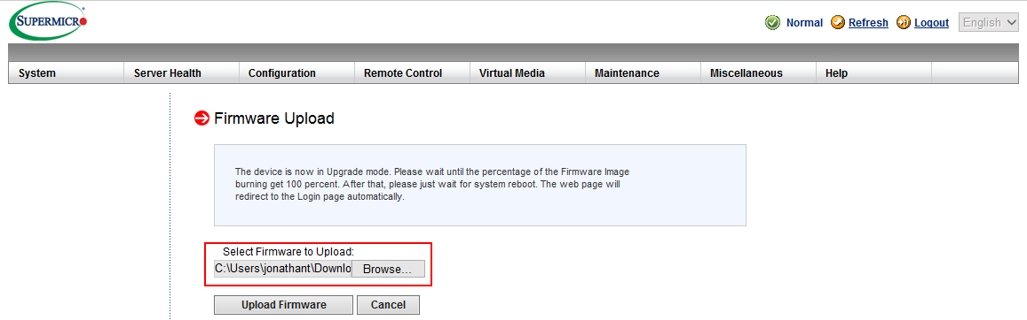

1.5 If Click <Cancel> to cancel firmware updates. Once you have clicked <Cancel > to update the IPMI Firmware, the following Firmware Upload screen will display as shown below.
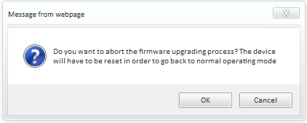

1.6 Click <Upload Firmware> to upload the selected firmware to the host server.
Warning! To properly update your firmware, do not interrupt the process until the process is completed. Once it is completed, the system will automatically reboot, and you will need to login to the server again.
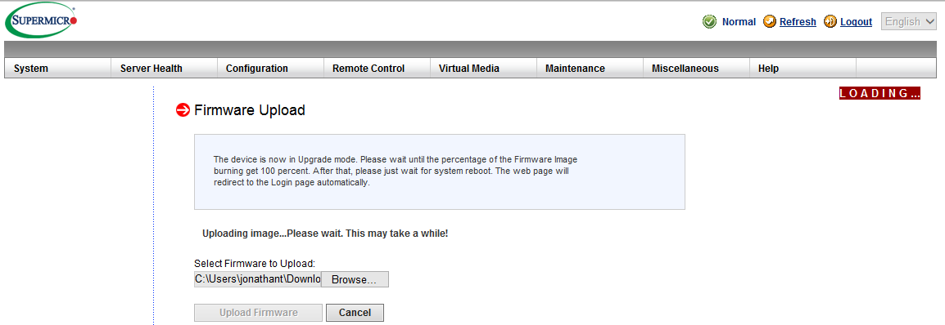
NOTE !!! Uncheck preserve configuration box during flashing (very important step for FW to work properly). All settings will be reset to default.
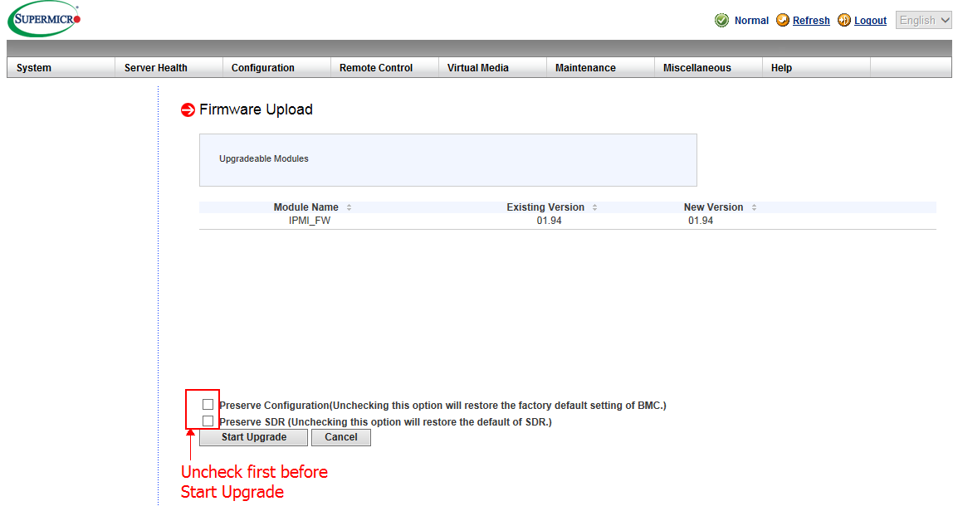

1.7 Click < Start upgrade > to download the firmware.
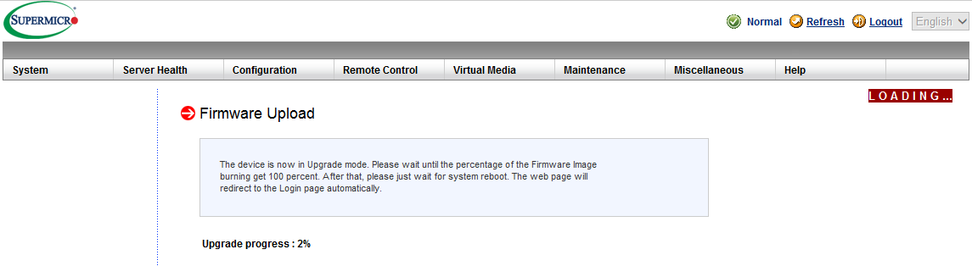
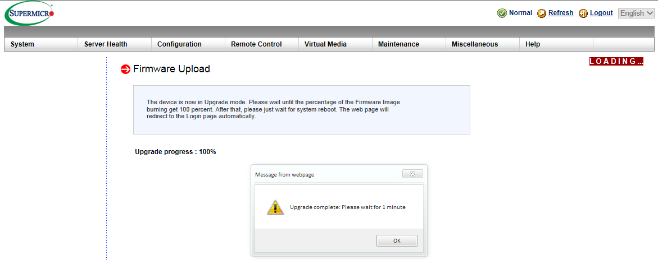1.8 Click < OK > System will reboot after upgrade complete. The web page will redirect to the login page automatically.

Firmware Updates in Windows, or Linux.

Instructions on how to use Flash Tools and Flash Tools Utility supports firmware.

The Flash Tools utility provides a complete solution for firmware updates. The user can flash the firmware using DOS, Windows or Linux. In addition, Windows and Linux allow the user to update the firmware via LAN or KCS.

Firmware Dumping

In addition to firmware updating, The Flash Tools also support firmware_dumping from the BMC (Baseboard Management Controller). You can use this feature to back up the firmware by dumping the current version of the firmware to an archive folder before updating to a new version. It will also allow you to fl ash other BMCs in the factory for mass production. Firmware_dumping is supported by DOS, Windows and Linux.

Windows/Linux Version of Flash Tools
In addition to DOS, the Flash Tools Utility supports Windows and Linux platforms.

The Windows/Linux version of Flash Tools Utility provides the same features supported by the DOS version. In addition, it also allows the user to update the firmware via LAN connections.

The main screen of the Windows/Linux version displays the information about the firmware and the instructions on how to use the utility as shown in Figure 1.

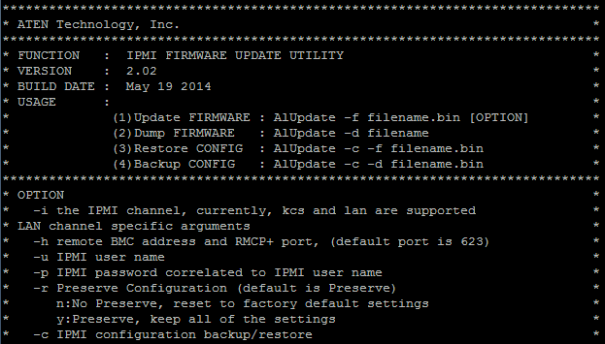
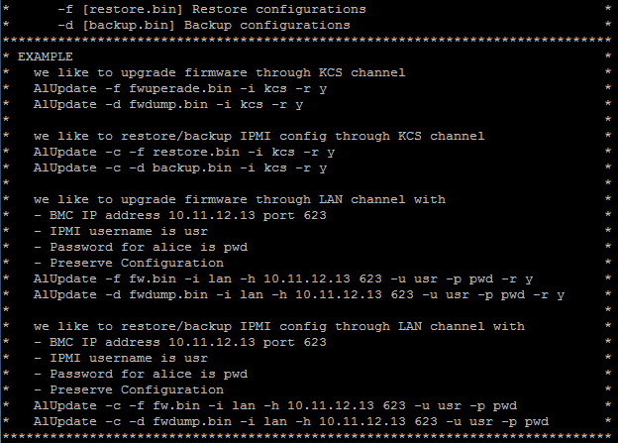
Figure 1: Main Screen of Flash Tools (in the Windows/Linux Version)
In the Windows/Linux version of the Flash Tools Utility, there are six parameters:
(1) -f: Type <-f> to enter the filename of the firmware that you want to update.
(2) -i: indicates the IPMI channel. Currently, KCS and LAN connections are supported. If a LAN connection is used, the user needs to enter the following parameters:
1. -h: Type <-h> to enter the addresses of the remote BMC and the RMCP+ port
(default port is 623).
2. -u: Type <-u> to enter the IPMI username.
3. -p: Type <-p> to enter the password for the IPMI user.
4. -r: Type <-r> to preserve (to save) the configuration settings you've entered.
(This feature is optional.) (Default: preserve configuration.)
5. y: Type <y> for the BMC to keep all settings after updating the firmware; otherwise, the BMC will reset the settings to factory default.

To connect IPMI via KCS, type <AwUpdate.exe/AlUpdate -f [filename.bin] -i kcs -r y> as shown in Figure 2.

Figure 2: Example of KCS FW Updates with/without Preserving Configuration
To connect IPMI via LAN, type:
<AwUpdate.exe/AlUpdate -f [filename.bin] -i lan -h 192.168.1.1 623 -u USER -p PWD -r y> as shown in Figure 3.

Figure 3: Example of LAN_FW_Updates through RMCP+ Port with/without Preserving Configuration.

After you've entered the commands above, the Flash Tools will start to update the firmware. There are two phases in firmware updating.

- Phase 1 is to transfer the FW image file to the BMC. In this phase, Flash Tools will transfer three parts to the BMC as shown in Figure 4.


Figure 4: Transferring (Parts 0, 1, 2 & 3)
- Phase 2 is to flash the new firmware. The progress of firmware updating will be displayed as shown in (Figure 7). The BMC will reboot after the firmware is completely updated. Please wait for the BMC to complete system reboot (Figure 8).

Figure 5: Progress of Firmware Updating
Figure 6: Updates Completed

